Neighbourhood Watch issues advice to protect yourself, loved ones and neighbours
MERA has received advice from the Neighbourhood Watch network which encourages residents to consider ways ‘to keep yourself, your loved ones and those in your community safe, particularly the isolated and vulnerable’ during the course of the coronavirus outbreak.
The communication sets out ten ways that everyone can protect themselves, their loved ones and others in the community as follows:
- Meet with household members, other relatives, friends and neighbours to discuss what to do if a COVID-19 outbreak occurs in your community and what the needs of each person will be. (Note – if you are concerned about neighbours who are not familiar with you, it may be wise to liaise with your Neighbourhood Watch Co-ordinator if you have one, or register yourself with the Thames Valley Neighbourhood Watch Network).
- If your neighbourhood has a website or social media page, consider joining it to maintain access to neighbours, information, and resources. Alternatively, share phone numbers and email addresses particularly with those who are isolated or vulnerable.
- Consider establishing a ‘buddy’ system within your community to ensure everyone stays connected to COVID-19 related news, services and can receive support safely, such as essentials deliveries.
- Plan ways to care for those who might be at greater risk for serious complications.
- Choose a room in your home that can be used to separate sick household members from those who are healthy.
- Learn how to self-isolate. Guidance can be found on the NHS website: https://www.nhs.uk/conditions/coronavirus-covid-19/self-isolation-advice/
- Create a list of local organisations that you and your neighbours can contact in the event that one of you needs access to information, healthcare services, support, or resources. Consider including organisations that provide mental health or counselling services, food, and other supplies.
- Create an emergency contact list of family, friends, neighbours, healthcare providers, teachers, employers, the local public health department, and other community resources.
- Learn about the emergency operations plan at your child’s school or childcare facility, and your employer’s emergency operations plan.
- Practice everyday preventive actions including regular hand washing.
  - The NHS provides guidance on how to wash hands: https://www.nhs.uk/live-well/healthy-body/best-way-to-wash-your-hands/.
  - The World Health Organisation provides guidance on basic protective measures: https://www.who.int/emergencies/diseases/novel-coronavirus-2019/advice-for-public
  - The Centre for Disease Control and Prevention provides guidance on handwashing for families https://www.cdc.gov/handwashing/handwashing-family.html
Residents are encouraged to follow advice from the Government as the course of the virus progresses.

MERA advises that practical guidance on social distancing and for vulnerable people can be found on the government’s website https://www.gov.uk/government/publications/covid-19-guidance-on-social-distancing-and-for-vulnerable-people

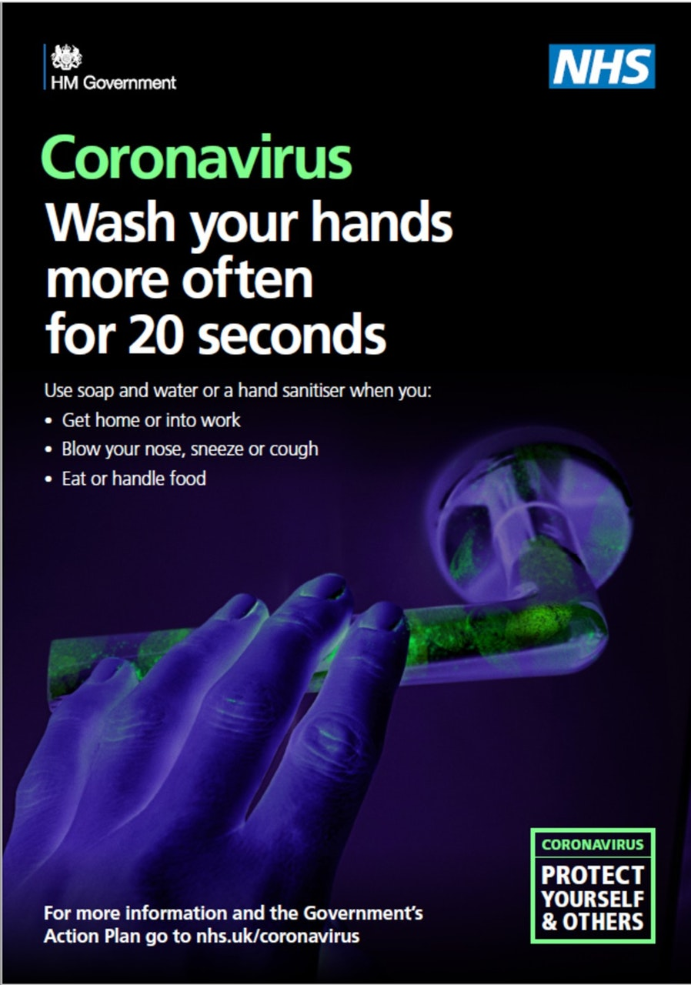
Message Sent By
Deborah Waller (NWN, Multi Scheme Administrator, England and Wales)
To reply or forward this email please use the buttons below or these links: Reply, Rate, Forward / Share.
To login to your account, click here, To report a fault, click here

